ZUNOBOT: Design and Preliminary Prototyping of a Modular, Explainable Assistive Robot for Personal Care
Abstract
As the global population ages and the healthcare workforce shrinks, the need for effective eldercare solutions has never been more critical. Socially Assistive Robots (SARs) offer a promising path forward, yet widespread adoption is currently stalled by high costs, rigid designs, and the "black box" nature of decision-making in platforms like Pepper or Care-O-bot. In this paper, we introduce the architectural framework and preliminary engineering prototype of ZUNOBOT, a personal care robot designed to overcome these barriers through affordability and transparency. The system leverages a split-computation model, using a Raspberry Pi 5 for high-level cognition and distributed STM32 microcontrollers for real-time actuation. Distinctively, ZUNOBOT addresses the challenge of user trust by integrating eXplainable AI (XAI) with Retrieval Augmented Generation (RAG) and Vision-Language Models (VLMs). This allows the robot to generate clear, human-readable explanations for its actions rather than just executing silent commands. We present the mechanical design of a scaled validation unit and the implementation of a transparency-focused interface. This study demonstrates the feasibility of our modular approach, offering a blueprint for a cost-effective, trustworthy, and human-centric robotic assistant.

Keywords: Elderly Care, Human-Robot Interaction (HRI), Socially Assistive Robots (SARs), Explainable AI (XAI), Modular Robotics, Aging-Population

1. Introduction

Driven by rapid changes in global demographics and healthcare, people are living longer while birth rates decline, leading to an accelerated aging of the global population [1], [7], [10]. This demographic shift presents significant socioeconomic challenges, particularly for the healthcare sector, which is struggling to meet the growing demand for eldercare services [5], [27]. Consequently, there is a critical need for effective solutions that enable older adults to maintain independence and age in place [24], [31].
Socially Assistive Robots (SARs) represent a promising solution to these challenges. These robots can assist with various daily living activities, facilitate cognitive stimulation, monitor health metrics, and provide companionship. They are explicitly designed to support caregivers and enhance the quality of life for older adults [1], [9]. Research demonstrates that SARs can improve emotional well-being, facilitate social interaction, and enhance cognitive and communication skills [7].
Despite their potential, widespread adoption of SARs is hindered by significant technical and implementation challenges [1], [7], [10], [30]. A primary barrier is limited functionality combined with high cost; many existing platforms perform only basic reminder tasks rather than offering personalized, meaningful support. Furthermore, most robots lack interoperability with external devices or healthcare systems, resulting in isolated solutions [7], [10]. Ethical concerns also persist, particularly the fear that robots might replace human interaction, potentially exacerbating loneliness, alongside issues regarding safety and privacy [1], [9], [16], [29]. Moreover, many platforms are not tailored to the specific capabilities or needs of the elderly, leading to low acceptance and utilization rates [5], [24].
Additionally, many autonomous systems operate as "black boxes," making decisions without transparent reasoning. This opacity erodes user trust, which is essential for long-term adoption [6], [17]. To address these gaps, we propose ZUNOBOT, a home caregiving assistant robot informed by a synthesis of recent literature. By utilizing cost-effective components such as the Raspberry Pi 5 and STM32 microcontrollers, ZUNOBOT is designed to be more accessible and robust than current commercial alternatives. Its modular construction facilitates the easy integration of new sensors and ensures compatibility with IoT ecosystems and medical devices.
Crucially, ZUNOBOT incorporates Explainable AI (XAI) to articulate its actions in natural language, fostering transparency [6], [17]. The system prioritizes natural voice interaction and is designed to collaborate with humans rather than replace them [5], [24], [26]. ZUNOBOT distinguishes itself through a balanced hardware architecture that leverages the computational power of CPUs for high-level cognition and the efficiency of MCUs for real-time control. This approach ensures affordability, ease of maintenance, and energy efficiency. Finally, the proposed perception suite enables intelligent navigation and situational awareness, ensuring safety in domestic environments.

2. Foundational Synthesizes
This review synthesizes insights from 30 academic papers to establish the foundational requirements and current gaps in personal care robotics, covering four key areas: (1) the state of eldercare robotics, (2) the role of voice interaction, (3) the imperative of explainability, and (4) the determinants of user acceptance.
2.1. State of Eldercare Robotics: Applications and Limitations
The new papers repeatedly emphasize robots' capabilities for transformative eldercare based on support for five overall types of intervention: physical help, social support, mental stimulation, health care supervision, and rehabilitation [Paper 1, Paper 7, Paper 10]. Physical activity and health care supervision are the overriding uses, with rehabilitation being the least researched [Paper 7, Paper 31].
Notable robots, such as Paro (zoomrophic), Pepper (anthropomorphic), and Care-O-bot (functional), illustrate varying design philosophies. Affection support was successful for Paro, social contact for Pepper, and task-related support for Care-O-bot, the latter showing high task performance [Paper 1, Paper 7]. Nonetheless, such systems have common problems worldwide. A chief concern is insufficient technological infrastructure; robots are often proprietary "islands" such that they prevent data consolidation and work with current healthcare infrastructure [Paper 7, Paper 10]. Their expensive nature, with accompanying narrow functionality, are also chief deterrents to widespread usage [Paper 10, Paper 31]. Research also cautions against the risk of social isolation should robots be seen, rather than supplement, replace human contact [Paper 9, Paper 16].
The papers urge a movement toward user-centered design and systems that support human-robot collaboration [Paper 16, Paper 28]. For example, the MORPHIA pilot showed a social connectivity facilitation communication robot did not have to decrease in-person visits but could be a complementing tool within a human network [Paper 28]. This is a match for older adults, who, although increasingly receptive to robot support for instrumental activities (e.g., housework, object manipulation), remain highly desirous of personal care, leisure, and high-priority health decision support from humans [Paper 5, Paper 24].
2.2. The Critical Role of Voice-Based Interaction
Speech interaction provides a hands-free, natural user interface, which is especially worthwhile for care situations, e.g., for a surgeon with busy hands [Paper 30] or for a mobility-disabled older person [Paper 12, Paper 18]. Increased deployment of Voice-based Personal Assistants (VPAs) such as Siri and Alexa in intelligent homes gives a good starting position for human-robot dialogue.
The proactive voice assistant experiments have shown acceptance to be extremely context-dependent. Proactive behaviour is valued high only when safety-critical events are involved, but at home, it might become intrusive or "patronizing" unless very carefully implemented [Paper 2]. This confirms that the ZUNOBOT's voice interaction should be reactive primarily or permission-asking initiation (indirect initiation) for non-critical interventions.
Furthermore, VPA trust studies discover certain intelligence traits that influence user perception [Paper 4, Paper 11]. Functional features (utility, ease of use) and hedonic features (innovativeness, pleasure) form competence-based trust for the VPA, which directly results in usage intention. Anthropomorphic features (autonomy, humanness), however, form integrity-based trust, which results in word-of-mouth, but not necessarily usage [Paper 11]. This posits that for ZUNOBOT adoption/in usage, its voice interface must be mainly useful, easy to use, and reliable (competence), but anthropomorphic features can reinforce perceived integrity for the VPA.
2.3. The Requirement for Explainability for Autonomous Robots
With increasing autonomy, the "black box" problem is a primary barrier for gaining user trust. The new field of eXplainable Autonomous Robots (XAR) focuses on explaining users about the decision-making processes of the robots [Paper 6, Paper 17].
Paper 6 makes a notable contribution by combining a Vision-Language Model (VLM) with a Large Language Model (LLM) to produce explanations. The system adopts a Retrieval Augmented Generation (RAG) approach, such that logs of the robot navigation system and text descriptions obtained from VLM analysis of images from the camera are indexed in a vector database. When a user asks the robot what it did, the system retrieves the corresponding context and synthesizes a textually readable explanation using an LLM (e.g., "I changed my path because I saw a person's hand with blue and white stripes") [Paper 6]. This multi-modal strategy greatly facilitates the accuracy and context-awareness of explanations over text-based logs.
Paper 17 also confirms application of LLMs for the generation of explanations, but reports problems with real-time responsiveness and a necessity for verbose, high-quality logs. For a eldercare robot such as ZUNOBOT, such explainability is a necessity, not a luxury. A person should have a clear idea of why a robot failed to deliver medicine on time or which path it selected. This is vital for safety, debugging, and gaining the confidence needed for long-term living together.

2.4. Determinants of User and Caregiver Acceptance
The implementation of care robots depends on a multidimensional integration of technological, user-related, and societal aspects [Paper 9].
Mature users value clear functionality and safely, reliably functioning robots. Aesthetic appeal is relevant; while humanoid or animal like appearance is often favoured, highly humanlike appearance risks creating a "uncanny valley" effect [Paper 9, Paper 26]. Mobility and speech interface enhance perceived sociability.
Ease of use and perceived usefulness are the top drivers, according to the Technology Acceptance Model (TAM) [Paper 4]. Personal traits such as technology anxiety decrease the usage intention-perceived competence association, calling for user-centric design [Paper 11]. Research also proves a distinct reversal of sentiments; senior citizens from 2023 were open to the help of robots for 18 additional household activities than interviewees questioned in 2014, due to broader exposure to technology such as smartphones [Paper 5, Paper 24].
Professional caregivers, along with family, greatly impact adoption choices [Paper 9]. Notably, robots should complement caregivers, not replace them. Paper 16, as well as Paper 29, contend that robots should make caregivers' work worthwhile through task offloading, thus giving time for more empathetic, person-centered attention. A badly thought-out robot whose maintenance or monitoring gives extra workforce burden on caregivers shall be resisted.
This paper identifies a compelling need for a next-generation care robot: affordable, interoperable, transparent, and built to support, rather than supplant, human care. The remainder of the next few sections outlines how ZUNOBOT is being created to fill this need.

3.1. Hardware Architecture
The hardware platform was selected to balance computational power with real-time capability, cost efficiency, and energy consumption.
3.1.1. Central Processing Unit (CPU): Raspberry Pi 5 The Raspberry Pi 5 serves as the central "brain" of the ZUNOBOT. This strategic selection offers three key advantages:
- Performance: Significantly more powerful than its predecessors, the Pi 5 handles the computational intensity of modern perception algorithms (e.g., facial and gesture recognition [13]) and real-time sensor fusion while executing the Robot Operating System (ROS 2) middleware.
- Affordability: It costs an order of magnitude less than the custom industrial PCs often used in research, directly addressing the cost barriers identified in previous studies [10], [31].
- Ecosystem: Extensive community support and compatibility with a wide array of peripherals (cameras, microphone HATs) facilitate rapid prototyping and modular expansion.
3.1.2. Microcontroller Units (MCUs): STM32 Family To ensure safety and precision, all time-critical actuation and sensor polling are offloaded to a distributed network of STM32 microcontrollers. This architecture offers several benefits [12]:
- Real-Time Performance: STM32 MCUs support hard real-time execution. This ensures accurate motor control and low-latency responses—essential for the safe operation of the mobile base—while freeing the Raspberry Pi to handle non-real-time cognitive tasks.
- Modularity and Robustness: Each major subsystem (e.g., the drive base, head unit) operates on its own dedicated MCU node. These nodes communicate via a CAN Bus (Controller Area Network), an industrial protocol renowned for its reliability in automotive and robotics applications. This modularity makes the system fault-tolerant and easy to upgrade or repair.
- Power Efficiency: The low power consumption of the MCUs contributes to extended battery life.
3.1.3. Suite for Perception
- Vision: A high-definition, Raspberry Pi-compatible camera module performs user recognition, gesture interpretation [13], and environmental monitoring.
- Auditory System: A high-performance loudspeaker and multi-microphone array form the core of the voice interaction system. The array supports beamforming to isolate speech in noisy environments, addressing robustness concerns highlighted in the literature [12], [18], [20].
- Navigation and Safety: The architecture supports a sensor suite including LiDAR and ultrasonic sensors for obstacle avoidance [14], [18], alongside Inertial Measurement Units (IMUs) and wheel encoders to ensure safe autonomous navigation.
3.1.4. Power System The system is powered by a rechargeable lithium-ion battery pack. Dedicated power management circuits and voltage regulators ensure a steady supply to all components [15]. The power architecture is designed to support self-sustaining operation, with logic in place to facilitate future autonomous docking and charging.

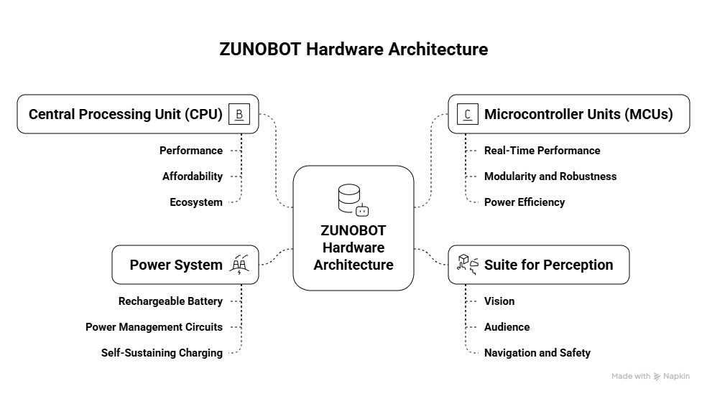

Figure 1 illustrates the high-level system architecture, organized into three distinct layers: (1) The Sensing/Actuation Layer (STM32 nodes), (2) The Control & Communication Layer (CAN Bus), and (3) The Cognition & Interaction Layer (Raspberry Pi 5 running ROS 2).

3.2. Software Architecture
The software is built upon ROS 2 (Robot Operating System 2), the industry standard for robotics R&D, ensuring interoperability and code reuse [27].
3.2.1. ROS 2 Framework ROS 2 provides a formal communication framework ideal for ZUNOBOT's distributed hardware. Key nodes include:
- Perception Node: Fuses data from cameras and microphones. It handles speech-to-text conversion (utilizing tools like Vosk or Google Speech APIs) and object recognition.
- Dialogue Manager Node: Manages user interaction. Based on findings from prior research [2], the system is primarily reactive but capable of limited, context-sensitive proactive interventions (e.g., safety alerts). It utilizes NLP frameworks such as Rasa [22] to parse user intent.
- Task Planner Node: Translates high-level commands (e.g., "bring my water bottle") into low-level action sequences. It employs path-planning algorithms ranging from A* for static environments to dynamic planners like RRT for changing conditions [3], [8], [13].
- Explainability Engine Node: A core pillar of the ZUNOBOT design, this node implements the Retrieval Augmented Generation (RAG) approach [6], [17].
3.2.2. The Explainability Engine: A RAG Pipeline This module is responsible for generating transparent explanations for the robot's actions. The process consists of four stages:
- Multi-Modal Logging: ZUNOBOT continuously logs planned paths, sensor data, and system states. Crucially, it uses Vision-Language Models (VLMs) to generate text descriptions of visual events (e.g., "a chair is obstructing the path") at regular intervals.
- Vector Embedding and Storing: These text logs and visual descriptions are converted into vector embeddings and stored in a local vector database (e.g., ChromaDB [17]), creating a searchable, multi-modal history of the robot's experiences.
- Context Retrieval: When a user asks a question (e.g., "Why did you stop?"), the system queries the vector database to retrieve the relevant logs and visual context from that specific moment.
- Explanation Generation: The retrieved context and the user's question are synthesized into a prompt for a local Large Language Model (LLM). The LLM generates a natural language explanation, such as: "I stopped because my sensors detected an object on the floor. My camera identified it as a slipper, so I halted to avoid tripping."

4. Design Rationale
The development of ZUNOBOT is grounded in the specific needs and gaps identified in our literature review. This section maps those academic insights directly to our engineering decisions, explaining why ZUNOBOT looks and behaves the way it does.
4.1. Prioritizing Affordability and Modularity A recurring theme in recent studies is that high acquisition costs prevent the widespread adoption of platforms like Pepper or Care-O-bot [10], [31]. To counter this, ZUNOBOT is engineered using cost-effective, off-the-shelf components—specifically the Raspberry Pi 5 and STM32 microcontrollers—to keep the bill of materials accessible for individuals and small care centers. Furthermore, we addressed the issue of "siloed" technology [7], [10] by adopting open standards: a CAN bus for hardware and ROS 2 for software. This modular approach transforms the robot from a static product into a versatile platform. A user might start with a basic model for companionship and later integrate specific medical modules, such as a vital signs monitor or a robotic arm, tailoring the solution to their evolving needs.
4.2. Engineering Trust through Explainability Trust is not a simple metric; it relies on two pillars: competence (the ability to do the job) and integrity (transparency in how the job is done) [4], [11]. The Explainability Engine is our primary mechanism for building this trust. By verbally articulating its reasoning, ZUNOBOT demonstrates competence (proving its sensors are working) and integrity (operating without hidden logic). This is crucial for healthcare scenarios; users have expressed a strong preference for understanding the logic behind decisions, especially regarding medication management [24]. A robot that can explain why it is issuing a reminder—referencing specific sensor data—is far more likely to be accepted than one that simply issues commands.

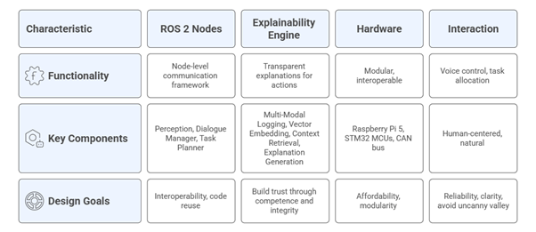
Figure 2. ZUNOBOT Design Aspects aiming for affordability, trust, and human-centered care.

4.3. Human-Centered Interaction Design For older adults who may struggle with mobility or dexterity, a hands-free voice interface is essential [12], [18]. However, we designed this interface to prioritize functional clarity over simulated personality. Research suggests that trust in assistants is built primarily on reliability [11], so ZUNOBOT focuses on executing commands accurately rather than pretending to be a human friend. Physically, we intentionally avoided the "uncanny valley" by selecting an appliance-like aesthetic rather than a humanoid one. The voice is polite but clearly robotic, avoiding the ethical pitfalls of deception or infantilization. In terms of behavior, we aligned the robot’s logic with user preferences for autonomy [5], [24]. The default operational mode is reactive—waiting for commands or asking for permission before acting—rather than being intrusively proactive, particularly in private matters like personal hygiene.
4.4. Complementing the Care Ecosystem A critical insight from recent literature is that robots must be designed to support meaningful care work, not replace the human element [16], [29]. ZUNOBOT serves as a tool for both the elderly user and their caregivers. By automating routine, low-level tasks—such as environmental monitoring or recurring reminders—the robot frees up caregivers to focus on empathetic social interaction. Additionally, the system offers peace of mind to distant family members through privacy-preserving summaries, similar to the goals of the MORPHIA project [28]. Instead of invasive video feeds, the Explainability Engine can generate natural language reports for the caregiver, such as: "Mr. Smith requested assistance finding his keys today and successfully completed his morning exercise routine." This collaborative approach ensures that technology acts as a bridge rather than a barrier, reducing social isolation while enhancing the overall quality of care.

5. Proposed Evaluation Framework
Since ZUNOBOT is currently in the prototyping phase, we have established a comprehensive evaluation framework to validate its performance against established benchmarks once the full-scale model is deployed. This framework combines quantitative technical testing with qualitative user-centric assessments.
5.1. Technical Performance Benchmarks
We intend to validate the system's core capabilities by benchmarking it against industry standards:
- Task Accuracy: We will quantify ZUNOBOT's reliability in navigation and manipulation tasks. Our goal is to approach the high standards set by established platforms, targeting the 96% task completion rate of Care-O-bot and the 94% reliability of GiraffPlus.
- Interaction Latency: To ensure natural communication, we will measure the response time of the voice interface in both quiet and noisy environments. The target benchmark is to achieve a response latency between 320–365 ms with a recognition accuracy exceeding 92%, aligning with results from comparable studies [18].
- Explainability Quality: A crucial metric for our architecture is the effectiveness of the XAI Engine. We will utilize standardized questionnaires to have users rate the clarity, helpfulness, and perceived trustworthiness of the robot's generated explanations.
5.2. Comparative Analysis
To contextualize ZUNOBOT’s position in the market, we conducted a feature-based comparison with current leading solutions. As summarized in Table 1, while other platforms excel in specific niches (such as Paro for therapy or Pepper for social interaction), ZUNOBOT distinguishes itself by targeting the gap for a holistic, affordable, and transparent solution.

Table 1. Comparative Analysis of ZUNOBOT against Representative Platforms
Robot System | Primary Function | Cost Estimate | Modularity | Explainability | Key Strength | Key Limitation
Pepper | Social Interaction | Very High (>$20k) | Limited | Limited or None | Human-like interaction | High cost; limited physical assistance
Care-O-bot | Physical Assistance | Very High (>$50k) | Low | Limited or None | Task accuracy & versatility | High cost; proprietary system
Paro | Emotional Support | High (~$5k) | None | N/A | Therapeutic effect | Single-purpose; passive
ZUNOBOT (Proposed) | Holistic Personal Care | Low (Target <$2k) | High (Modular HW/SW) | High (Integrated XAI Engine) | Affordability, Transparency, Customizability | Prototype stage; requires validation

5.3. User-Centric Validation
Adhering to a human-centered design philosophy [26], [28], future phases will involve long-term pilot studies with older adults and their caregivers in both simulated and real-world home environments. These studies will focus on three key dimensions:
- Usability and Acceptance: We will utilize validated instruments, such as the Almere Model or the DSRA (Device-Specific Robot Acceptance) scale [26], to quantify how useful and easy to use participants find the system.
- Quality of Life Impact: The study will measure changes in the user's emotional well-being, social connectedness, and perceived sense of independence after living with the robot.
- Caregiver Burden: A critical goal of ZUNOBOT is to support the support network. We will assess the system's ability to reduce caregiver stress and workload, validating the collaborative care model discussed in recent literature [16], [29].

6. System Implementation and Preliminary Results
To validate the proposed modular architecture, a preliminary system implementation was carried out focusing on mechanical design feasibility and human–robot interaction capability. A physical engineering prototype was designed using the Fusion 360 CAD environment, while the interaction subsystem was implemented on a Raspberry Pi 5 platform. The implementation was intentionally scoped to verify structural safety, modular integration, and interaction transparency, which are critical for assistive robots operating in domestic environments.
6.1 Mechanical Design and Scaled Prototyping To validate our modular architecture and safety concepts prior to full-scale fabrication, a scaled engineering prototype was designed and assembled. This miniature iteration serves as a development platform to verify structural integrity, thermal management, and software integration in a controlled environment.
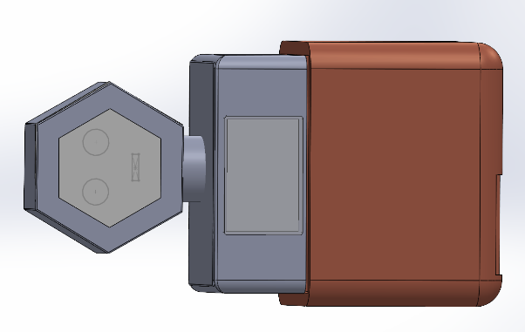
The mobile base chassis of the prototype features a compact footprint of 200 mm × 180 mm, enabling extensive maneuverability testing in confined indoor spaces. As illustrated in Figure 3, the chassis adopts a rounded rectangular ("squircle") geometry with a fillet radius of 35 mm on all exposed edges. This geometric configuration was selected to reduce the likelihood of sharp-edge contact during low-speed interactions with users or household objects, thereby improving operational safety.

Figure 3. Top-down view of the ZUNOBOT scaled engineering prototype. The design features a "squircle" chassis (200 × 180 mm) to minimize sharp edges, a protective shell enclosure for the electronics, and a modular hexagonal head unit.
A differential-drive configuration is centrally aligned within the chassis to support zero-radius turning, which is essential for navigation in narrow spaces. Dedicated mounting slots were incorporated into the base plate to allow precise alignment of the drive motors while maintaining mechanical rigidity.
The vertical structure follows a shell-based enclosure design that separates the internal electronic components from the external environment. The body shell, with a total assembly height of 30 cm, is rigidly mounted to the base plate and encloses the power distribution circuitry, battery management system, and low-level control electronics. This separation provides physical protection and ensures that heat generated by computation and power regulation does not directly affect the motor actuation subsystem.
The complete assembly integrates the mobile base with a modular head unit mounted on a cylindrical neck. This configuration supports an appliance-like appearance rather than a humanoid form, aligning with the design objective of minimizing discomfort or unrealistic expectations commonly associated with anthropomorphic robots.
6.2 Interaction Subsystem Implementation To evaluate the human-centric interaction layer, a dedicated Human–Machine Interface (HMI) was implemented using the Streamlit framework, executed locally on the Raspberry Pi 5. The interface design emphasizes clarity, high contrast, and minimal cognitive load, making it suitable for elderly users and first-time operators.
As illustrated in Figure 5, the HMI dashboard is structured into three primary functional regions:
- Real-Time System Diagnostics: The upper section provides continuous feedback on key system parameters, including processor utilization, battery charge level, and operational state. During testing, the system operated at an average CPU load of approximately 40%, with a measured battery level of 74%, indicating sufficient headroom for concurrent interaction and control tasks.
- State Visualization Panel: The central region presents a simplified visual representation of the robot’s internal state, such as Ready, Listening, or Processing. This non-verbal feedback mechanism allows users to understand the robot’s current behavior without requiring technical interpretation.
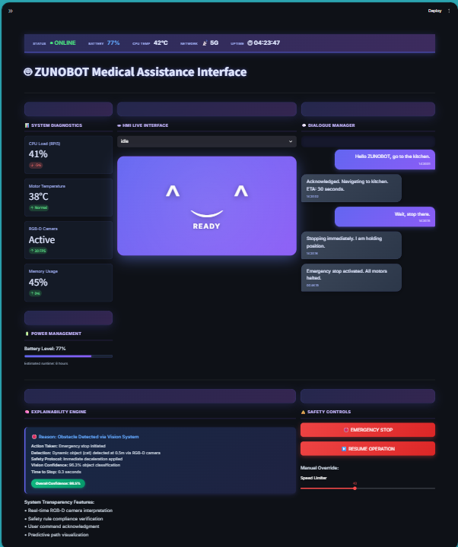
- Explainability Console: The lower section implements the Explainability Engine interface. It converts internal decision outcomes into concise natural-language descriptions. For example, when a safety stop condition is triggered, the system logs both the detected cause (e.g., "Obstacle Detected") and the corresponding action taken. This approach ensures transparency in autonomous behavior and supports user trust by clearly communicating why specific actions occur.

Figure 5. The implemented Human–Machine Interface (HMI) running on the Raspberry Pi 5. It features real-time diagnostics (top), a state visualization panel (center), and the Explainability Console (bottom) which translates sensor data into human-readable reasons for robot actions.
The successful execution of the HMI on embedded hardware demonstrates the feasibility of deploying explainable, user-facing interfaces directly on low-power robotic platforms.
6.3 Summary of Preliminary Results The implemented prototype validates the feasibility of the proposed modular architecture at both mechanical and interaction levels. The CAD-based mechanical design confirms safe geometry, compactness, and modular integration, while the interaction subsystem demonstrates real-time status feedback and explainable behavior communication. Although full autonomous navigation and long-term field testing are ongoing, the presented results establish a solid foundation for further system integration and experimental evaluation.

7. Conclusion
Supporting an aging global population requires solutions that are not just technologically advanced, but also accessible and deeply human-centered. While Socially Assistive Robots (SARs) hold immense potential, their impact has been limited by prohibitive costs, proprietary restrictions, and the "black box" nature of autonomous decision-making.
In this work, we presented the architectural design and preliminary engineering validation of ZUNOBOT, a system built to dismantle these barriers. By leveraging cost-effective hardware like the Raspberry Pi 5 and STM32 microcontrollers, we demonstrated that advanced robotic capabilities do not require expensive, custom-built platforms. Furthermore, the integration of our Explainability Engine—which translates complex sensor data into plain language—addresses the critical need for transparency, ensuring that users understand why the robot acts the way it does.
Crucially, ZUNOBOT is designed to complement the care ecosystem, not disrupt it. It serves as a tireless assistant that handles routine monitoring and reminders, allowing human caregivers to focus on empathy and connection. The successful development of our scaled prototype and interaction interface validates the feasibility of this modular approach, proving that safety and clarity can be engineered into the core of the system.
Future Work Moving forward, our focus will shift from component-level validation to full-scale deployment. The immediate next step is to translate the validated "squircle" geometry and software architecture into a full-size mobile platform capable of navigating real homes. Following this, we plan to conduct longitudinal user studies to quantify the impact of our Explainability Engine on user trust.
Long-term development will explore integrating wearable health sensors for real-time vital monitoring and establishing secure cloud bridges to keep family members informed. Ultimately, we aim to evolve ZUNOBOT from a responsive prototype into a proactive, empathetic companion—one that empowers older adults to live with greater independence, dignity, and peace of mind.

References
- Intervention scenarios and robot capabilities for support, guidance and health monitoring for the elderly [doi.org]
- Proactive behaviour in voice assistants: A systematic review and conceptual model [doi.org]
- A survey of autonomous robots and multi-robot navigation: Perception, planning and collaboration [doi.org]
- Voice-based personal assistant (VPA) trust: Investigating competence and integrity [doi.org]
- Human Versus Robot Assistance: Older Adults’ Preferences for Assistance on Domestic Tasks [DOI: 10.1177/30495334251360417]
- New technologies and assistive robotics for elderly: A review on psychological variables [doi.org]
- Enhancing Robot Explanation Capabilities through Vision-Language Models: a Preliminary Study by Interpreting Visual Inputs for Improved Human-Robot Interaction []
- Robotics in Elderly Healthcare: A Qualitative Analysis of 20 Recent European Research Projects [https://doi.org/10.1145/3711936]
- A Comprehensive Review on Autonomous Navigation [https://doi.org/10.1145/3727642]
- Aging with robots: A brief review on eldercare automation [dx.doi.org]
- Adoption of Artificial Intelligence–Enabled Robots in Long-Term Care Homes by Health Care Providers: Scoping Review [dx.doi.org]
- Voice-Controlled Robotics in Early Education: Implementing and Validating Child-Directed Interactions Using a Collaborative Robot and Artificial Intelligence [doi.org]
- Speech Recognition-Based Wireless Control System for Mobile Robotics: Design, Implementation, and Analysis [doi.org]
- Autonomous Robot for Elderly Safety and Assistance []
- Voice Controlled and Obstacles Detection Robotic Vehicle [doi.org]
- Development of an Android-Based, Voice-Controlled Autonomous Robotic Vehicle [doi.org]
- Explaining Autonomy: Enhancing Human-Robot Interaction through Explanation Generation with Large Language Models []
- VOICE CONTROLLED AND OBSTACLE AVOIDANCE ROBOTIC CAR USING MOBILE []
- VOICE CONTROLLED ROBOT USING NODE-MCU [www.doi.org]
- VOICE CONTROL ROBOT: A SURVEY [www.doi.org]
- Editorial: Assistive and service robots for health and home applications (RH3 - Robot Helpers in Health and Home) [doi.org]
- A VOICE ASSISTANT WITH SECURE AI AND ML (NEXUS) []
- Integrating Large Language Models into Robotic Autonomy: A Review of Motion, Voice, and Training Pipelines [doi.org]
- The Conversation is the Command: Interacting with Real-World Autonomous Robot Through Natural Language [doi.org]
- Voice-Controlled Pick and Place Robot [DOI: 10.48175/568]
- User Acceptance of a Home Robotic Assistant for Individuals With Physical Disabilities: Explorative Qualitative Study [dx.doi.org]
- A Review on the Use of Mobile Service Robots in Elderly Care [https://doi.org/10.3390/robotics11060127]
- A Mobile Robotic Assistant to Improve Social Care Networking for Older and Frail People at Home: Main Results of the MORPHIA-Project [doi.org]
- Socially assistive robots and meaningful work: the case of aged care [doi.org]
- Scenario-Based Programming of Voice-Controlled Medical Robotic Systems [doi.org]

